INTRODUCTION TO JAVA
WEEK 4: ERRORS IN JAVA
DAY 1: COMPILE TIME/SYNTAX ERRORS

UNDERSTANDING ERRORS IN JAVA

In java errors occurs when your program fails to compile or program crashes when executing or the program doesn’t produce the desired results. You can encounter all or some these scenarios as a programmer/ developer, and your ability to fix or rectify errors is one of the most important skills you can possess as a programmer.

Complier Errors
Runtime Errors
Logic Errors

COMPILE ERRORS AND SYNTAX

Remember that the compiler converts from Java code (which humans can read) to Java byte code (which computers can read). The Java compiler is a lot like a translator. Now imagine that you told a translator to translate “giberderrmishdbed” from English to French. The translator would tell you that “giberderrmishdbed” isn’t a word, so it can’t be translated!

That’s what happens when you write code that the compiler doesn’t understand. It doesn’t know how to translate your code into Java byte code, so it gives you an error. The rules of a language are called its syntax. Compiler errors are also called syntax errors, because it means that your code broke the rules of the language.

Compiler errors can be for things like forgotten semicolons or misspelled variables, but they can also be for violating the rules of Java, like using a non-static variable from a static function.

Runtime Errors
A runtime error (or exceptional event) is a problem that arises during the execution of a program. When a runtime error occurs, the normal flow of the program is disrupted and the program/Application terminates abnormally, which is not recommended, therefore, a runtime errors are to be handled so as to avoid program/application crash.
A runtime error can occur for many different reasons. Following are some scenarios where a runtime error occurs.
- A user has entered an invalid data.
- A file that needs to be opened cannot be found.
- A network connection has been lost in the middle of communications or the JVM has run out of memory.
Some of these exceptions are caused by user error, others by programmer error, and others by physical resources that have failed in some manner.
Runtime errors are not picked by the compiler, hence can only occur when running/executing the program.
Example
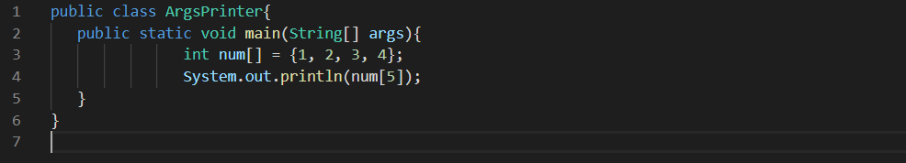
If you execute the program you will get an error and your program will crash abruptly. Will get the following output;
Exception in thread "main" java.lang.ArrayIndexOutOfBoundsException: 5
at Exceptions.Unchecked_Demo.main(ArgsPrinter.java:4)
Let’s examine the output message in detail so that it helps us interpret what:
- The Exception in thread "main" part tells us that we got a runtime error.
- The java.lang.ArrayIndexOutOfBoundsException part tells you what type of error occurred. This is a class name that you can look up in the Java API. In this case, we’re getting an ArrayIndexOutOfBoundsException, which the Java API tells us means that “the index is either negative or greater than or equal to the size of the array.”
- The 5 part gives you more information about the error. In this case it’s telling us that we tried to access the 5th index of an array.
- The at ArgsPrinter.main(ArgsPrinter.java:4) part is called a stack trace, and it tells us which class, function, and line number the error occured on. In this case, the error occured on line 4 of the ArgsPrinter class, inside the main() function.

Exception Handling
Runtime error can be handling such the if they happen to occur then the effect will not be devastating this is called exception handling. exception handling mechanism to handle the runtime errors so that normal flow of the application can be maintained.

Ways to handle exceptions
Java try block
Java try block is used to enclose the code that might throw an exception. It must be used within the method.
If an exception occurs at the particular statement of try block, the rest of the block code will not execute. So, it is recommended not to keeping the code in try block that will not throw an exception.
Java try block must be followed by either catch or finally block.

Java catch block
Java catch block is used to handle the Exception by declaring the type of exception within the parameter. The declared exception must be the parent class exception ( i.e., Exception) or the generated exception type. However, the good approach is to declare the generated type of exception.
The catch block must be used after the try block only. You can use multiple catch block with a single try block.
try{
//code that may throw an exception
}catch(Exception_class_Name ref){
}
Java finally block
- Java finally block is a block that is used to execute important code such as closing connection, stream etc.
- Java finally block is always executed whether exception is handled or not.
- Java finally block follows try or catch block
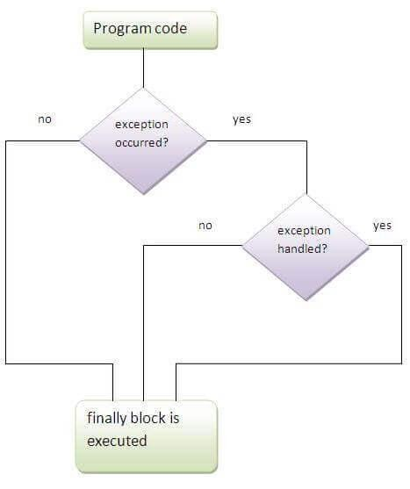
try{
//code that may throw an exception
}catch(Exception_class_Name ref){
} finally{

ERRORS IN JAVA - ACTIVITY 1

Certainly! Let me address your questions:

1. Custom Exception in Java:
A custom exception in Java is an exception that is defined by the programmer to handle specific conditions in the program. This allows for more fine-grained exception handling, as different types of exceptions can be created to represent different error scenarios.
How to Implement Custom Exception in Java:

To implement a custom exception in Java, you need to create a new class that extends either the `Exception` class or one of its subclasses (like `RuntimeException`), depending on whether you want to create a checked or unchecked custom exception.

Here's an example of how to create a custom checked exception:

// Custom checked exception
class CustomCheckedException extends Exception {
public CustomCheckedException(String message) {
super(message);
}
}

// Example of using the custom checked exception
public class CustomExceptionExample {
public static void main(String[] args) {
try {
throw new CustomCheckedException("This is a custom checked exception");
} catch (CustomCheckedException e) {
System.out.println("Caught custom checked exception: " + e.getMessage());
}
}
}

And here's an example of how to create a custom unchecked exception:
// Custom unchecked exception
class CustomUncheckedException extends RuntimeException {
public CustomUncheckedException(String message) {
super(message);
}
}

// Example of using the custom unchecked exception
public class CustomExceptionExample {
public static void main(String[] args) {
throw new CustomUncheckedException("This is a custom unchecked exception");
}
}
2. Using `throw` to Handle Exceptions in Java:

In Java, the `throw` keyword is used to explicitly throw an exception. When a specific condition is met, and you want to signal an exceptional situation, you can use `throw` to throw an instance of a particular exception.

Here's a simple example:

public class ThrowExample {
public static void main(String[] args) {
try {
int result = divide(10, 0);
System.out.println("Result: " + result);
} catch (ArithmeticException e) {
System.out.println("Exception caught: " + e.getMessage());
}
}

public static int divide(int numerator, int denominator) {
if (denominator == 0) {
// Using throw to explicitly throw an ArithmeticException
throw new ArithmeticException("Cannot divide by zero");
}
return numerator / denominator;
}
}
In this example, the `divide` method throws an `ArithmeticException` if the denominator is zero. The `try-catch` block in the `main` method catches this exception and handles it accordingly. The `throw` statement is used to trigger the exception explicitly.

DAY 2: LOGIC ERRORS
Sometimes you’ll write code that compiles, and doesn’t throw any runtime exceptions, but still doesn’t work how you expected it to. This is almost always caused by a logic error, and it’s usually a result of the programmer (that’s you!) making an assumption or a typo. In most instances Logic Errors are not easily identifiable, they can be identified by through testing especially by comparing the expected results to actual results from the program.
At times logic error will go unnoticed for some time, such that an application can be deployed on production with these errors.
The lesson is that even if you write code that compiles and runs without any exceptions, it still might contain logic errors. This doesn’t mean you’re a bad programmer! They happen all the time to every single one of us.
DEBUGGING

Importance of Debugging:

- Debugging is a crucial process in finding and reducing bugs or defects in computer programs.
- All errors arise from the premise that something thought to be right was, in fact, wrong.
- Debugging is essential for programmers to identify and resolve errors.

Four Main Steps in Debugging:

1. Localizing a Bug:
- Inexperienced programmers may find bug localization challenging.
- Spotting a bug can be difficult, and the first step is to locate where the error is emanating from.
2. Classifying the Error:
- Errors can be classified as compile errors, runtime errors, or logic errors.
- Proper classification is essential for effective bug fixing.
3. Understanding an Error:
- Fully understand the error before attempting to fix it.
- A checklist is provided to guide the investigation process.
4. Repairing an Error:
- Fixing an error involves more than modifying code; it requires proper documentation.
- Learning from mistakes is emphasized, and a checklist is recommended for recording relevant information.

General Debugging Techniques:
1. Exploiting Compiler Features: Static analysis by Java compilers can help detect basic semantic problems and syntax errors.
2. Abused println() Debugging Technique: Adding print statements for tracking control flow and data values is discouraged due to its ad-hoc nature and inefficiency.
3. Logging: Logging messages in Java using tools like log4j can help monitor program status and diagnose problems.
4. Defensive Programming and Assertions: Assertions are expressions that should evaluate to true at a specific point in the code, aiding in error detection.
5. ACI Debugging Technique: ACI stands for "Automobile Club d’Italia," suggesting the idea of explaining code to someone else as a form of peer review.
6. Reading the Code Through: Reading and annotating code away from the computer can provide a fresh perspective and understanding.
7. The Debugger: Debuggers allow interactive code inspection, line-by-line execution, and variable inspection to identify and fix problems. Breakpoints and watchpoints are essential features in debugging tools.

LOGGING IN JAVA
Logging in Java is a crucial aspect of application development. It helps developers understand the flow of the program, diagnose issues, and monitor the application's behavior. Java provides a built-in logging framework called `java.util.logging` as part of the Java Standard Edition (SE) platform.

Here's a basic guide on how to use logging in Java:

1. Import the Logging Package:
import java.util.logging.*;

2. Create a Logger Instance:
// Naming convention: Use the fully qualified class name as the logger name
Logger logger = Logger.getLogger(MyClass.class.getName());

3. Configure the Logger (Optional):
// Set the logging level (FINEST, FINER, FINE, CONFIG, INFO, WARNING, SEVERE)
logger.setLevel(Level.INFO);

// Create a ConsoleHandler to log messages to the console
ConsoleHandler consoleHandler = new ConsoleHandler();
consoleHandler.setLevel(Level.ALL);
logger.addHandler(consoleHandler);

4. Log Messages:
logger.severe("This is a severe message");
logger.warning("This is a warning message");
logger.info("This is an info message");
logger.config("This is a config message");
logger.fine("This is a fine message");
logger.finer("This is a finer message");
logger.finest("This is the finest message");
Example:
import java.util.logging.*;

public class LoggingExample {
private static final Logger logger = Logger.getLogger(LoggingExample.class.getName());

public static void main(String[] args) {
// Optionally, configure the logger
logger.setLevel(Level.INFO);

// Log messages
logger.severe("This is a severe message");
logger.warning("This is a warning message");
logger.info("This is an info message");
logger.config("This is a config message");
logger.fine("This is a fine message");
logger.finer("This is a finer message");
logger.finest("This is the finest message");
}
}
Log Handlers and Formatters:
Java logging allows you to configure handlers and formatters to control where and how log messages are output. For example, you can use a `FileHandler` to write logs to a file, or a `SocketHandler` to send logs to a remote server.

FileHandler fileHandler = new FileHandler("mylogfile.log");
logger.addHandler(fileHandler);
// Custom formatter
SimpleFormatter formatter = new SimpleFormatter();
fileHandler.setFormatter(formatter);

Logging Levels:
- SEVERE: Highest value; indicates a serious failure.
- WARNING: Indicates a potential problem.
- INFO: Provides informational messages.
- CONFIG: Configuration information.
- FINE, FINER, FINEST: Increasing levels of detail for debugging.

Logging Best Practices:
- Use meaningful log messages.
- Choose the appropriate log level.
- Avoid logging sensitive information.
- Configure log levels based on the environment (e.g., development, testing, production).
- Consider using logging frameworks like Log4j or SLF4J for more advanced features.

Adjust the logging configuration based on your specific requirements and the needs of your application.
The Debugger in NetBeans

NetBeans, an integrated development environment (IDE), comes with a built-in debugger that allows you to analyze and troubleshoot your Java applications. Here's a brief overview of using the debugger in NetBeans:

Setting Breakpoints:
1. Open NetBeans: Launch NetBeans and open the Java project you want to debug.
2. Locate the Code: Navigate to the Java source code where you want to start debugging.
3. Set a Breakpoint: Click in the left margin of the source code editor next to the line where you want to start debugging. This sets a breakpoint, and when your program reaches that line, it will pause execution.
Debugging Process:
1. Start Debugging: Click on the "Debug Project" button (a green bug icon) in the toolbar, or use the "Debug" menu option.
2. Execution Pauses at Breakpoint: When your program reaches the line with the breakpoint, execution pauses, and the debugger becomes active.
3. Inspect Variables: In the "Variables" window, you can inspect the values of variables at the current execution point.
4. Step Through Code: Use the "Step Into," "Step Over," and "Step Out" buttons to navigate through your code one line at a time.
5. Resume Execution: Click on the "Resume" button to continue running the program until the next breakpoint is encountered or the program completes.

6. View Call Stack: The "Call Stack" window shows the sequence of method calls leading to the current point in your code.
7. Evaluate Expressions: You can use the "Watches" window to evaluate expressions and monitor their values.
8. Inspect Threads: The "Threads" window allows you to inspect and control threads in your application.
Additional Debugger Features:
- Conditional Breakpoints: Right-click on a breakpoint and set conditions for it to be triggered.

- **Exception Breakpoints:** Break when an exception of a specified type is thrown.

- **Data Tips:** Hover over variables in your code to see their current values.

- **Inspect Objects:** You can inspect objects and their contents during debugging.

- **Profiling:** NetBeans also provides profiling tools for performance analysis.

Example:
Suppose you have the following Java code:
public class DebugExample {
public static void main(String[] args) {
int a = 5;
int b = 10;
int sum = addNumbers(a, b);
System.out.println("Sum: " + sum);
}
private static int addNumbers(int x, int y) {
int result = x + y;
return result;
}
}
1. Set a breakpoint at the `int result = x + y;` line.
2. Click on the "Debug Project" button.
3. The debugger will pause execution at the breakpoint, allowing you to inspect variables and step through the code.
Remember to explore the various windows provided by the NetBeans debugger to get a comprehensive view of your application's state during debugging.

DAY 3: COMMON ERRORS IN JAVA

COMMON ERRORS IN JAVA

Runtime Errors:

ArrayIndexOutOfBoundsException: Accessing an array index outside its bounds.
StringIndexOutOfBoundsException: Trying to access part of a string beyond its length.
NullPointerException: Attempting to use an object reference with a null value.
NoClassDefFoundError: Class file with the main method not found at runtime.
NoSuchMethodFoundError: Attempting to call a method that no longer exists.
NoSuchProviderException: Requesting an unavailable security provider.
AccessControlException: Denied access to system resources.
ArrayStoreException: Violating rules of casting elements in arrays.
Bad Magic Number: Incorrect first four bytes in a class file.
Broken Pipe: Data stream from a file or network socket is closed.
Could Not Create Java Virtual Machine: Incorrect invocation or memory allocation.
ClassCastException: Trying to cast an object to the wrong class.
ClassFormatError: Class file cannot be read or interpreted correctly.
ClassNotFoundException: Class that was present during compilation is missing at runtime.
ExceptionInInitializerError: Something went wrong with static initialization.
IllegalBlockSizeException: Length of the message during decryption is not a multiple of 8 bytes.
BadPaddingException: Incorrect padding during encryption or decryption.
IncompatibleClassChangeError: Base class changes after compilation of a child class.
FileNotFoundException: Attempt to access a non-existent file.
EOFException: Unexpected end of file or stream during input.
UnsupportedEncodingException: Character encoding is not supported.
SocketException: Error creating or accessing a socket.
SSLException: Failure in SSL-related operations.
MissingResourceException: Resource is missing, often due to misconfigured properties file.
NoInitialContextException: Unable to create a connection for naming operation.
NoSuchElementException: Attempting to access the next element when none exists.
NoSuchFieldError: Accessing a field that no longer exists in an object.
NumberFormatException: Invalid string-to-numeric conversion.
TimeoutException: Blocking operation times out.
It's crucial to understand these errors and their causes to write robust and error-free Java code. Always consider proper exception handling and debugging techniques to address and prevent these issues.

Factory Method Patterns
A factory pattern or factory method pattern defines an interface or abstract class for creating an object, but uses the subclasses to decide which class to use in the following instances:
- when a class doesn't know what subclasses will be required to be created,
- when a class wants the subclasses to specify the objects that are to be created, and
- when the parent classes choose the creation of objects for its subclasses.
The following example of unified modelling language (UML) describes the design of code to be used using a factory method pattern.
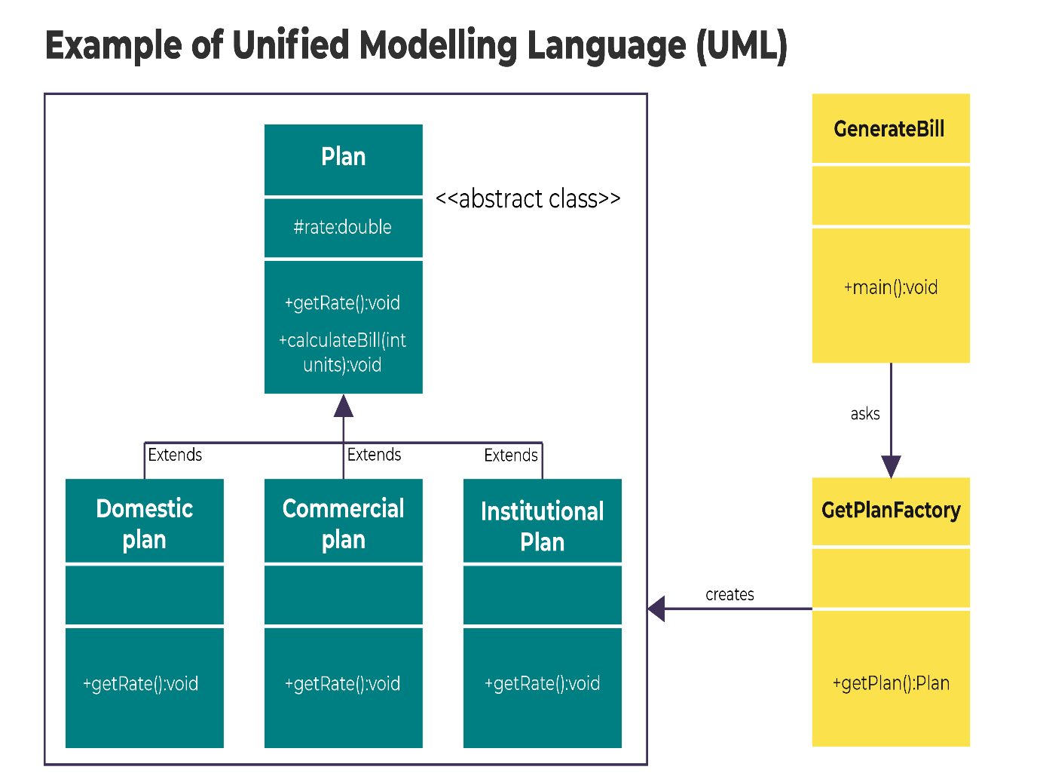
The above UML shows that the example is going to create a Plan abstract class and concrete classes that extend the Plan abstract class. A factory class GetPlanFactory is defined as a next step. The GenerateBill class will use GetPlanFactory to get a Plan object. It will pass information (DOMESTICPLAN / COMMERCIALPLAN / INSTITUTIONALPLAN) to GetPlanFactory to get the type of object it needs.
DAY 4: CODE REFACTORING

What is refactoring?
Software mostly starts on a small scale, and most of it is well-designed. However, over time, software size and complexity increases and bugs creep in. Therefore code reliability decreases. Software developers, particularly when they are not the original authors, therefore find it increasingly more difficult to maintain the code and to extend it. The codebase, which in any software company should be a valuable asset, at some point can become a liability.
Refactoring is, therefore, a powerful Agile technique that is used by developers to improve existing software. When a system's source code is easily understandable, the system is more maintainable, leading to reduced costs and allowing precious development resources to be used elsewhere. At the same time, if the code is well structured, new requirements can be introduced more efficiently and with fewer problems
Refactoring simply means "improving the design of existing code without changing its observable behaviour". Each refactoring process is a simple process that makes one logical change to the structure of the code. When changing a lot of code at one time it is possible that bugs were introduced. If, however, a change is implemented in small steps with tests run after each step, the bug most likely would surface in the test run immediately after introducing it into the system. The step can then be examined or, after executing the step, it could be split into even smaller steps which can be applied afterward.
The two development tasks, maintenance, and enhancement, often are in conflict because new features, especially those that do not fit cleanly within the original design, result in an increased maintenance effort. The refactoring process aims to reduce this conflict, by aiding non-destructive changes to the structure of the source code.
(Source: http://wiki.c2.com/?WhatIsRefactoring. Accessed 8 April 2020)
The phases of refactoring
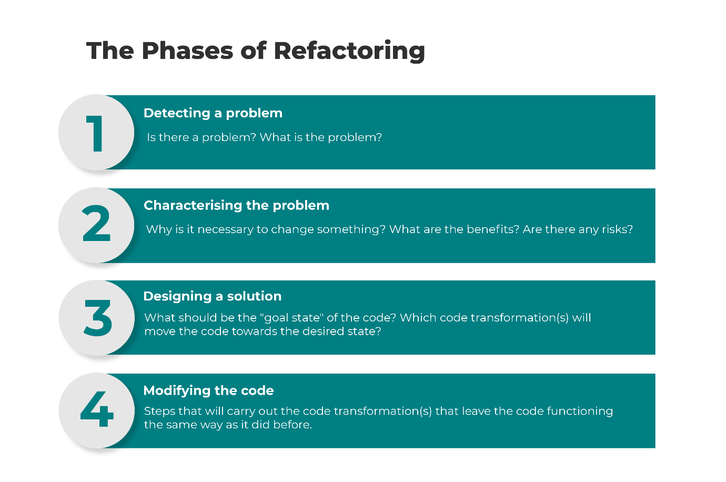
A refactoring operation proceeds roughly via the following phases:
- Detecting a problem – Is there a problem? What is the problem?
- Characterising the problem – Why is it necessary to change something? What are the benefits? Are there any risks?
- Designing a solution – What should be the "goal state" of the code? Which code transformation(s) will move the code towards the desired state?
- Modifying the code – Steps that will carry out the code transformation(s) that leave the code functioning the same way as it did before.
When should one consider refactoring?
Ideally, refactoring would be part of a continuous quality improvement process. In other words, refactoring would be seamlessly interwoven with other day-to-day activities of every software developer.
Refactoring may be useful when a bug has surfaced and the problem needs to be fixed, or the code needs to be extended. Refactoring at the same time as maintenance or adding new features, also means that management and developers are more likely to allow it, since it will not require an extra phase of testing.
When doing refactoring the externally observable behaviour must be guaranteed to stay the same. If refactoring is carried out manually, one needs to frequently rebuild the system and run tests. Manual refactoring is therefore really practical only when the following conditions are in place :
- The system, of which the refactored code is a part, can be rebuilt quickly.
- There are automated "regression" tests that can be frequently run.
Examples of Refactoring
A few examples of refactoring are as follows:
- Renaming
This is used when a method, variable, class or other Java item has a name that is misleading or confusing. This requires all references, and potentially file locations to be updated. The process of renaming a method may include renaming the method in subclasses as well as clients. On the other hand, renaming a package will also involve moving files and directories, and updating the source control system.
- Moving a class
This is used when a class is in the wrong package. It should, therefore, be moved to another package where it fits better. All import statements or fully qualified names referring to the given class need to be updated. The file will also have to be moved and updated in the source control system.
- Extract method
This is used when a long method needs to be broken up to enhance readability and maintainability. A section of code with a single logical task (e.g. finding a record by id) is replaced with an invocation to a new method.
- Extracting a superclass
This is used when an existing class provides functionality that needs to be modified in some way. An abstract class is introduced as the parent of the current class, and then common behaviour is "pulled up" into this new parent. Clients of the existing class are changed to reference the new parent class, allowing alternative implementations (polymorphism).

